Atal Bihari Vajpayee - Indian Institute Of Information Technology And Management

# BLOOD BANK MANAGEMENT

INTRODUCTION

##### ❏ Blood is the vital connection to having a healthy body, and according to the American Red Cross, nearly 5 million people receive blood transfusions each year. Thanks to years of research, much progress has been made towards making transfusions [safer and more](https://www.hematology.org/about/history/50-years/transfusion-medicine-advances) [effective](https://www.hematology.org/about/history/50-years/transfusion-medicine-advances).

❏ Blood banking refers to the process of collecting, separating, and storing blood. The first U.S. blood bank was established in 1936. Today, blood banks collect blood and separate it into its various components so they can be used most effectively according to the needs of the patient.

##### ❏ With the above reference in mind, we have created this Blood Bank Project which includes the frontend and backend. For the frontend, Html, CSS, and Javascript languages are used. The database is made using MySql workbench.

❏ The ER Diagram for the same is shown below. Also, the report contains the pieces of code for table creation and data entry, addition, and updation. Apart from this, It also contains the screenshots of code for frontend and the final website.

ENTITIES AND ATTRIBUTES

1. Donors
   * Name
   * Phone number(multivalued attribute)
   * Donor id(primary key)
   * Age(derived attribute from DOB)
   * Gender(simple attribute)
   * Address(Composite attribute) 2.Blood bank
   * Name
   * Blood group
   * Address
   * License number
   * Ownership
   * Quantity 3.Blood
   * Group
   * Cost
2. Blood bank Manager
   * Name
   * Address (composite attribute:location,district,state)
   * Phone number
   * Email id

RELATIONS

1. Donates is the relation between donors and blood(many-many)
   * The blood table contains the cost per unit blood and the blood group where the blood group is the primary key
   * And in the Donor’s table, we have the primary key as the name of the Donor and the phone number
2. Registers is the relation between donors and blood bank(many-one)
   * Blood bank name, city, blood group and phone number are the attribute address
3. Manages is the relation between blood bank and blood bank manager(one-one)
   * The blood bank manager has the manager’s name, bank name, phone no. and the email address
   * The blood bank table has the blood bank name, location, type, ownership, and Annual quantity

## ER DIAGRAM

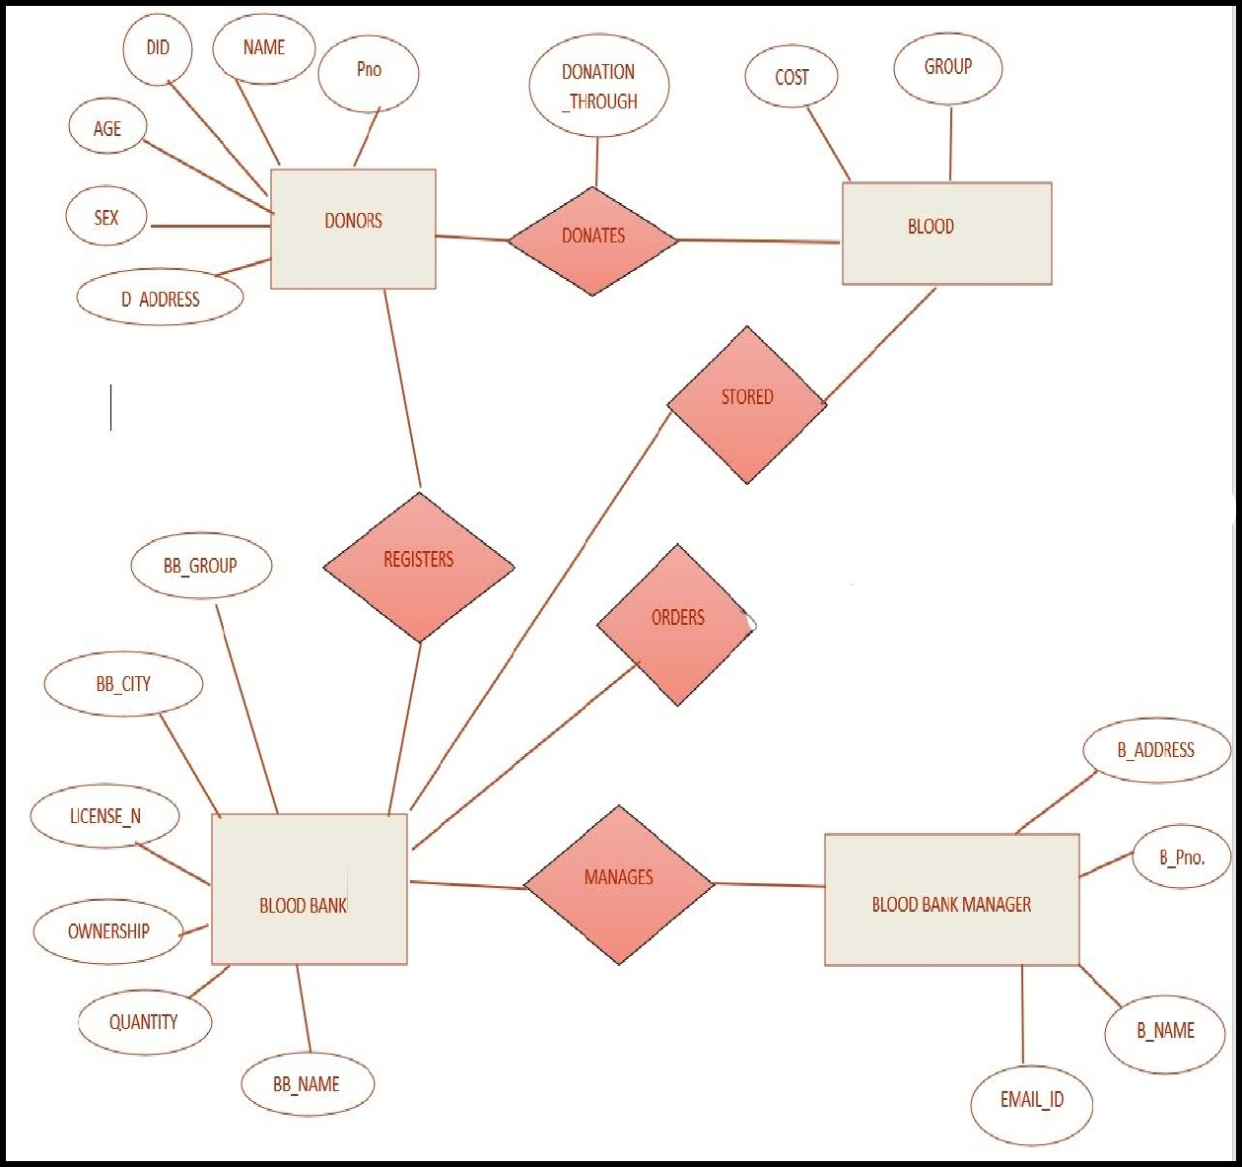

TABLES

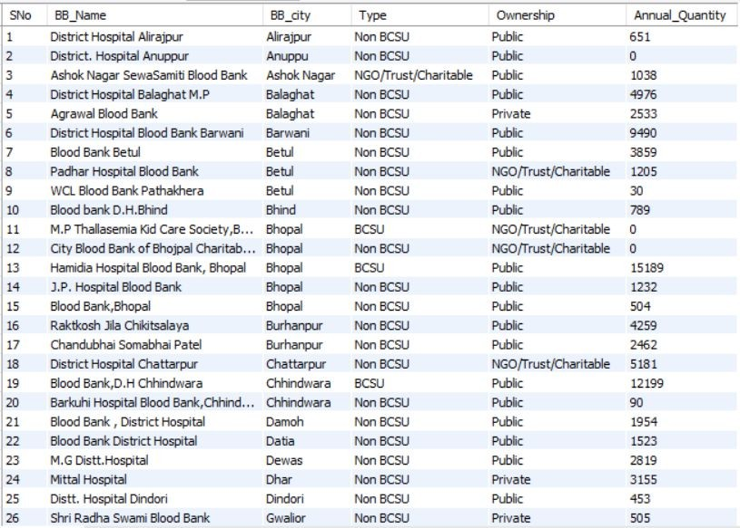



Blood Bank

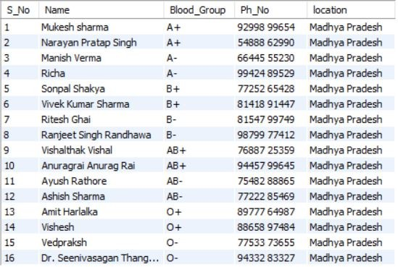

##### Donors

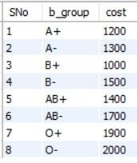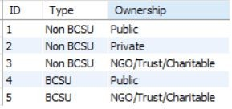

Blood Cost Type Of Blood Banks

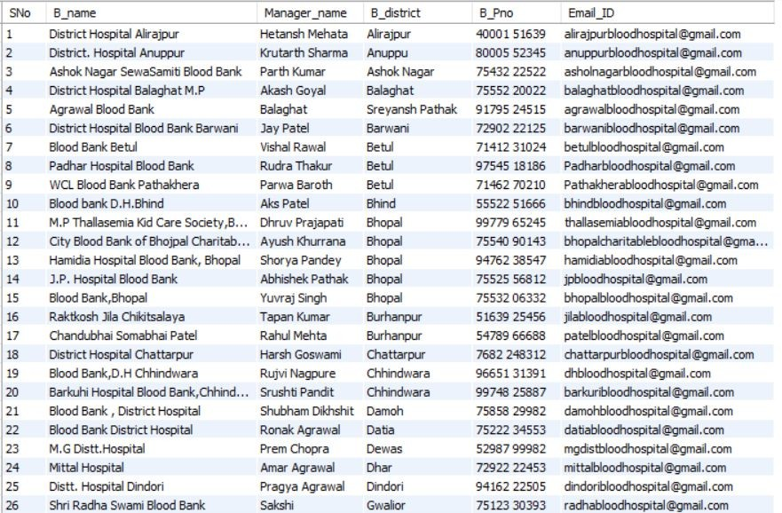



Blood Bank Manager

## NORMALIZED TABLES

❏ Normalization using BCNF.

❏ It is made by using the Blood Bank and Type of blood bank’s table.

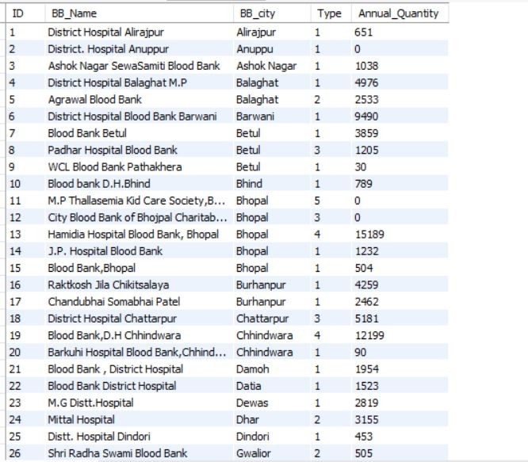

Second Normalized Table

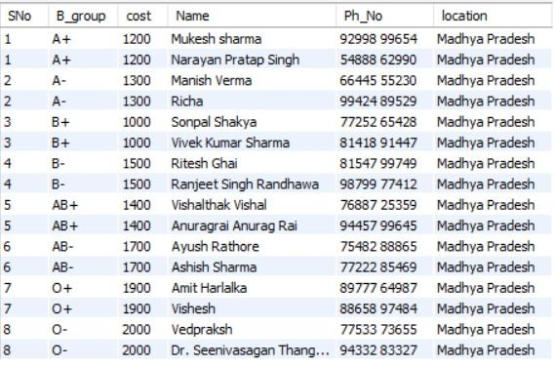

##### We have the blood group and the cost from table blood.

Remaining columns (Name,Phone number and location)from the Donor’s table

❏ **Code for Normalizing Tables**

create table bloodd (

SNo int, B_group char(5), cost int,

Name char(55),

Ph_No char(20), location char(20)

);

insert into bloodd values(1,"A+",1200,"Mukesh sharma""92998 99654","Madhya Pradesh");

insert into bloodd values(2,"A+",1200,"Narayan Pratap Singh","54888 62990","Madhya Pradesh");

insert into bloodd values(3,"A-",1300,"Manish Verma","66445 55230","Madhya Pradesh");

insert into bloodd values(4,"A-",1300,"Richa","99424 89529","Madhya Pradesh"); insert into bloodd values(5,"B+",1000,"Sonpal Shakya","77252 65428","Madhya Pradesh");

insert into bloodd values(6,"B+",1000,"Vivek Kumar Sharma","81418 91447","Madhya Pradesh");

insert into bloodd values(7,"B-",1500,"Ritesh Ghai","81547 99749","Madhya Pradesh"); insert into bloodd values(8,"B-",1500,"Ranjeet Singh Randhawa","98799 77412","Madhya Pradesh");

insert into bloodd values(9,"AB+",1400,"Vishalthak Vishal","76887 25359","Madhya Pradesh");

insert into bloodd values(10,"AB+",1400,"Anuragrai Anurag Rai","94457 99645","Madhya Pradesh");

insert into bloodd values(11,"AB-",1700,"Ayush Rathore","75482 88865","Madhya Pradesh");

insert into bloodd values(12,"AB-",1700,"Ashish Sharma","77222 85469","Madhya Pradesh");

insert into bloodd values(13,"O+",1900,"Amit Harlalka","89777 64987","Madhya Pradesh");

insert into bloodd values(14,"O+",1900,"Vishesh","88658 97484","Madhya Pradesh"); insert into bloodd values(15,"O-",2000,"Vedpraksh","77533 73655","Madhya Pradesh"); insert into bloodd values(16,"O-",2000,"Dr. Seenivasagan Thangaraj","94332 83327","Madhya Pradesh");

## EXAMPLES OF QUERIES PROCESSING

#### First Query:

##### ❏ Statement

Display the Name, Phone number, and location of the donor in decreasing order of the donor's name with the cost of 1 unit blood of their blood type where the cost of any of the blood type is greater than 1000.

##### ❏ Codes:

select S_No,Name,Blood_Group,Cost,Ph_No,location from blood b ,donors d

where b.b_group=d.Blood_group having b.cost>1000

order by d.Name desc;

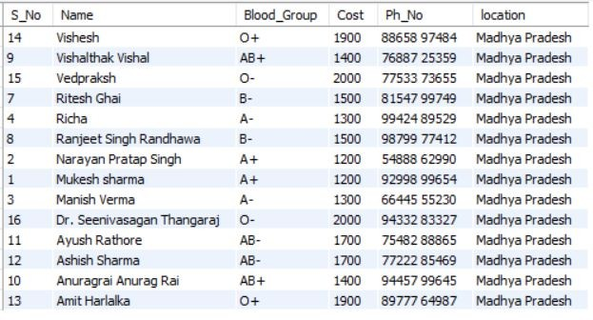❏ Output:

#### Second Query:

##### ❏ Statement:

display all the details of blood bank and its manager with the type of blood bank and its ownership with Blood Bank name in the decreasing order and having annual quantity of blood greater then 200;

##### ❏ Codes:

select ID_,BB_Name,BB_city,Annual_Quantity,Type,Ownership,Manager_name,

B_Pno,Email_ID

from new_BloodBank nb,Type_Table t,blood_bank_manager bb where nb.ID_=bb.SNo and t.ID=nb.type_

having nb.Annual_Quantity>200 order by nb.BB_Name desc;

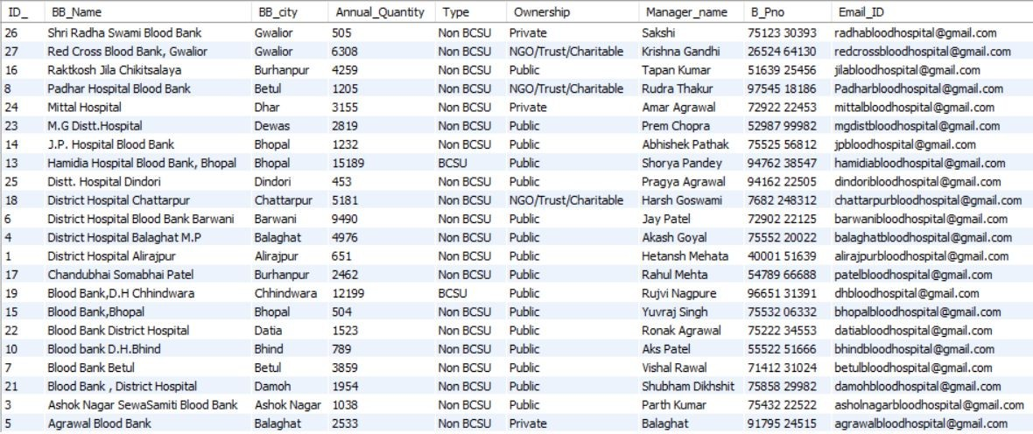Output:

#### Third Query:

##### ❏ Statement:

Update the annual quantity of the blood bank whose type and ownership is BCSU and NGO/Trust/Charitable to 555;

##### ❏ Codes:

update Blood_Bank b

set b.Annual_Quantity=555

where b.Type="BCSU " and b.Ownership="NGO/Trust/Charitable";

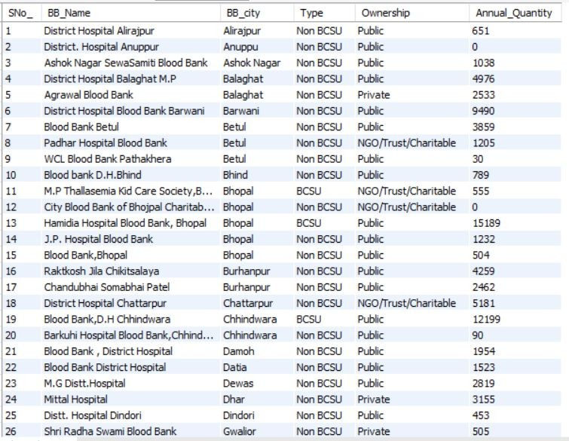❏ Output:

#### PART 1:

(Table Blood)

create database DBS;

## Appendix 1

##### (MySQL codes to create tables)

use DBS;

create table Table1( SNo int,

COMPONENT char(90), DISCRIPTION char(120)

);

insert into Table1 values(1,"General"," Basic details, Ownership, Category,License, etc.");

insert into Table1 values(2,"Collection and VBD"," Annual Collection, VNRBD and donor management");

insert into Table1 values(3,"Technical – IH, TTIs,components","Methods, Performances.");

insert into Table1 values(4,"Quality Management System ","Check for compliance to guidelines and standards");

insert into Table1 values(5,"HR, Training, and Equipment"," Availability and Participation");

select * from table1;

drop table table1;

create table Blood( SNo int,

b_group char(5), cost int);

insert into blood values(1,"A+",1200); insert into blood values(2,"A-",1300); insert into blood values(3,"B+",1000); insert into blood values(4,"B-",1500);

insert into blood values(5,"AB+",1400); insert into blood values(6,"AB-",1700); insert into blood values(7,"O+",1900); insert into blood values(8,"O-",2000);

PART 2:

select * from blood;

(Table Blood Bank Manager)

create table blood_bank_ manager

(

SNo int,

B_name char(50), B_district char(50), B_Pno char(12), Email_ID char(50)

);

insert into blood_bank_manager values(1,"District Hospital Alirajpur","Alirajpur","40001 51639","[alirajpurbloodhospital@gmail.com](mailto:alirajpurbloodhospital@gmail.com)"); insert into blood_bank_manager values(2,"District. Hospital Anuppur","Anuppu","80005 52345","[anuppurbloodhospital@gmail.com](mailto:anuppurbloodhospital@gmail.com)"); insert into blood_bank_manager values(3,"Ashok Nagar SewaSamiti Blood Bank","Ashok Nagar","75432 22522","[asholnagarbloodhospital@gmail.com](mailto:asholnagarbloodhospital@gmail.com)");

insert into blood_bank_manager values(4,"District Hospital Balaghat M.P","Balaghat","75552 20022","[balaghatbloodhospital@gmail.com](mailto:balaghatbloodhospital@gmail.com)"); insert into blood_bank_manager values(5,"Agrawal Blood Bank","Balaghat","91795 24515","[agrawalbloodhospital@gmail.com](mailto:agrawalbloodhospital@gmail.com)"); insert into blood_bank_manager values(6,"District Hospital Blood Bank Barwani","Barwani","72902 22125","[barwanibloodhospital@gmail.com](mailto:barwanibloodhospital@gmail.com)");

insert into blood_bank_manager values(7,"Blood Bank Betul","Betul","71412 31024","[betulbloodhospital@gmail.com](mailto:betulbloodhospital@gmail.com)");

insert into blood_bank_manager values(8,"Padhar Hospital Blood Bank","Betul","97545 18186","[Padharbloodhospital@gmail.com](mailto:Padharbloodhospital@gmail.com)"); insert into blood_bank_manager values(9,"WCL Blood Bank

Pathakhera","Betul","71462 70210","[Pathakherabloodhospital@gmail.com](mailto:Pathakherabloodhospital@gmail.com)");

insert into blood_bank_manager values(10,"Blood bank D.H.Bhind","Bhind","55522 51666","[bhindbloodhospital@gmail.com](mailto:bhindbloodhospital@gmail.com)"); insert into blood_bank_manager values(11,"M.P Thallasemia Kid Care Society,Bhopal Blood bank","Bhopal","99779 65245","[thallasemiabloodhospital@gmail.com](mailto:thallasemiabloodhospital@gmail.com)");

insert into blood_bank_manager values(12,"City Blood Bank of Bhojpal Charitable Trust","Bhopal","75540 90143","[bhopalcharitablebloodhospital@gmail.com](mailto:bhopalcharitablebloodhospital@gmail.com)");

insert into blood_bank_manager values(13,"Hamidia Hospital Blood Bank, Bhopal","Bhopal","94762 38547","[hamidiabloodhospital@gmail.com](mailto:hamidiabloodhospital@gmail.com)"); insert into blood_bank_manager values(14,"J.P. Hospital Blood Bank","Bhopal","75525 56812","[jpbloodhospital@gmail.com](mailto:jpbloodhospital@gmail.com)");

insert into blood_bank_manager values(15,"Blood Bank,Bhopal","Bhopal","75532 06332","[bhopalbloodhospital@gmail.com](mailto:bhopalbloodhospital@gmail.com)"); insert into blood_bank_manager values(16,"Raktkosh Jila Chikitsalaya","Burhanpur","51639 25456","[jilabloodhospital@gmail.com](mailto:jilabloodhospital@gmail.com)"); insert into blood_bank_manager values(17,"Chandubhai Somabhai Patel ","Burhanpur","54789 66688","[patelbloodhospital@gmail.com](mailto:patelbloodhospital@gmail.com)");

insert into blood_bank_manager values(18,"District Hospital Chattarpur","Chattarpur","7682 248312","[chattarpurbloodhospital@gmail.com](mailto:chattarpurbloodhospital@gmail.com)");

insert into blood_bank_manager values(19,"Blood Bank,D.H Chhindwara","Chhindwara","96651 31391","[dhbloodhospital@gmail.com](mailto:dhbloodhospital@gmail.com)"); insert into blood_bank_manager values(20,"Barkuhi Hospital Blood Bank,Chhindvara","Chhindwara","99748 25887","[barkuribloodhospital@gmail.com](mailto:barkuribloodhospital@gmail.com)");

insert into blood_bank_manager values(21,"Blood Bank , District Hospital","Damoh","75858 29982","[damohbloodhospital@gmail.com](mailto:damohbloodhospital@gmail.com)"); insert into blood_bank_manager values(22,"Blood Bank District Hospital","Datia","75222 34553","[datiabloodhospital@gmail.com](mailto:datiabloodhospital@gmail.com)"); insert into blood_bank_manager values(23,"M.G

Distt.Hospital","Dewas","52987 99982","[mgdistbloodhospital@gmail.com](mailto:mgdistbloodhospital@gmail.com)"); insert into blood_bank_manager values(24,"Mittal Hospital ","Dhar","72922 22453","[mittalbloodhospital@gmail.com](mailto:mittalbloodhospital@gmail.com)");

insert into blood_bank_manager values(25,"Distt. Hospital Dindori","Dindori","94162 22505","[dindoribloodhospital@gmail.com](mailto:dindoribloodhospital@gmail.com)"); insert into blood_bank_manager values(26,"Shri Radha Swami Blood Bank","Gwalior","75123 30393","[radhabloodhospital@gmail.com](mailto:radhabloodhospital@gmail.com)"); insert into blood_bank_manager values(27,"Red Cross Blood Bank, Gwalior","Gwalior","26524 64130","[redcrossbloodhospital@gmail.com](mailto:redcrossbloodhospital@gmail.com)"); select *

from blood_bank_manager;

drop table blood_bank_manager;

Part 3:

(Table Blood Bank)

create table Blood_Bank

(

SNo int,

BB_Name char(50), BB_city char(20), Type char(20), Ownership char(20), Annual_Quantity int

);

insert into Blood_Bank values (1,"District Hospital Alirajpur","Alirajpur","Non BCSU ","Public" ,651);

insert into Blood_Bank values (2,"District. Hospital Anuppur","Anuppu","Non BCSU ","Public" ,0);

insert into Blood_Bank values (3,"Ashok Nagar SewaSamiti Blood Bank","Ashok Nagar","NGO/Trust/Charitable ","Public" ,1038); insert into Blood_Bank values (4,"District Hospital Balaghat M.P","Balaghat","Non BCSU ","Public" ,4976);

insert into Blood_Bank values (5,"Agrawal Blood Bank","Balaghat","Non BCSU ","Private" ,2533);

insert into Blood_Bank values (6,"District Hospital Blood Bank Barwani","Barwani","Non BCSU ","Public" ,9490);

insert into Blood_Bank values (7,"Blood Bank Betul","Betul","Non BCSU ","Public" ,3859);

insert into Blood_Bank values (8,"Padhar Hospital Blood Bank","Betul","Non BCSU ","NGO/Trust/Charitable" ,1205);

insert into Blood_Bank values (9,"WCL Blood Bank Pathakhera","Betul","Non BCSU ","Public" ,30);

insert into Blood_Bank values (10,"Blood bank D.H.Bhind","Bhind","Non BCSU ","Public" ,789);

insert into Blood_Bank values (11,"M.P Thallasemia Kid Care Society,Bhopal Blood bank","Bhopal","BCSU ","NGO/Trust/Charitable" ,0);

insert into Blood_Bank values (12,"City Blood Bank of Bhojpal Charitable Trust","Bhopal","Non BCSU ","NGO/Trust/Charitable" ,0);

insert into Blood_Bank values (13,"Hamidia Hospital Blood Bank, Bhopal","Bhopal","BCSU ","Public" ,15189);

insert into Blood_Bank values (14,"J.P. Hospital Blood Bank","Bhopal","Non BCSU ","Public" ,1232);

insert into Blood_Bank values (15,"Blood Bank,Bhopal","Bhopal","Non BCSU ","Public" ,504);

insert into Blood_Bank values (16,"Raktkosh Jila Chikitsalaya","Burhanpur","Non BCSU ","Public" ,4259);

insert into Blood_Bank values (17,"Chandubhai Somabhai Patel ","Burhanpur","Non BCSU ","Public" ,2462);

insert into Blood_Bank values (18,"District Hospital Chattarpur","Chattarpur","Non BCSU ","NGO/Trust/Charitable",5181); insert into Blood_Bank values (19,"Blood Bank,D.H Chhindwara","Chhindwara","BCSU ","Public" ,12199);

insert into Blood_Bank values (20,"Barkuhi Hospital Blood Bank,Chhindwara","Chhindwara","Non BCSU ","Public" ,90); insert into Blood_Bank values (21,"Blood Bank , District Hospital","Damoh","Non BCSU ","Public" ,1954);

insert into Blood_Bank values (22,"Blood Bank District Hospital","Datia","Non BCSU ","Public" ,1523);

insert into Blood_Bank values (23,"M.G Distt.Hospital","Dewas","Non BCSU ","Public" ,2819);

insert into Blood_Bank values (24,"Mittal Hospital ","Dhar","Non BCSU ","Private",3155);

insert into Blood_Bank values (25,"Distt. Hospital Dindori","Dindori","Non BCSU ","Public" ,453);

insert into Blood_Bank values (26,"Shri Radha Swami Blood Bank","Gwalior","Non BCSU ","Private" ,505);

insert into Blood_Bank values (27,"Red Cross Blood Bank, Gwalior","Gwalior","Non BCSU ","NGO/Trust/Charitable",6308 ); select *

from Blood_Bank;

create table Type_Table ( ID int,

Type char(10), Ownership char(30)

);

insert into Type_Table values(1,"Non BCSU","Public"); insert into Type_Table values(2,"Non BCSU","Private");

insert into Type_Table values(3,"Non BCSU","NGO/Trust/Charitable"); insert into Type_Table values(4,"BCSU","Public");

insert into Type_Table values(5,"BCSU","NGO/Trust/Charitable");

select *

#### PART 4:

from type_table;

(Table New_blood Bank)

create table new_BloodBank

(

ID int,

BB_Name char(50), BB_city char(20), Type int, Annual_Quantity int

);

insert into new_BloodBank values (1,"District Hospital Alirajpur","Alirajpur",1,651);

insert into new_BloodBank values (2,"District. Hospital Anuppur","Anuppu",1 ,0);

insert into new_BloodBank values (3,"Ashok Nagar SewaSamiti Blood Bank","Ashok Nagar",1 ,1038);

insert into new_BloodBank values (4,"District Hospital Balaghat M.P","Balaghat",1 ,4976);

insert into new_BloodBank values (5,"Agrawal Blood Bank","Balaghat",2 ,2533);

insert into new_BloodBank values (6,"District Hospital Blood Bank Barwani","Barwani",1 ,9490);

insert into new_BloodBank values (7,"Blood Bank Betul","Betul",1

,3859);

insert into new_BloodBank values (8,"Padhar Hospital Blood Bank","Betul",3,1205);

insert into new_BloodBank values (9,"WCL Blood Bank Pathakhera","Betul",1,30);

insert into new_BloodBank values (10,"Blood bank D.H.Bhind","Bhind",1,789);

insert into new_BloodBank values (11,"M.P Thallasemia Kid Care Society,Bhopal Blood bank","Bhopal",5,0);

insert into new_BloodBank values (12,"City Blood Bank of Bhojpal Charitable Trust","Bhopal",3,0);

insert into new_BloodBank values (13,"Hamidia Hospital Blood Bank, Bhopal","Bhopal",4 ,15189);

insert into new_BloodBank values (14,"J.P. Hospital Blood Bank","Bhopal",1,1232);

PART 5:

(Table Donor)

insert into new_BloodBank values (15,"Blood Bank,Bhopal","Bhopal",1,504);

insert into new_BloodBank values (16,"Raktkosh Jila Chikitsalaya","Burhanpur",1 ,4259);

insert into new_BloodBank values (17,"Chandubhai Somabhai Patel ","Burhanpur",1 ,2462);

insert into new_BloodBank values (18,"District Hospital Chattarpur","Chattarpur",3,5181);

insert into new_BloodBank values (19,"Blood Bank,D.H Chhindwara","Chhindwara",4 ,12199);

insert into new_BloodBank values (20,"Barkuhi Hospital Blood Bank,Chhindwara","Chhindwara",1 ,90);

insert into new_BloodBank values (21,"Blood Bank , District Hospital","Damoh",1,1954);

insert into new_BloodBank values (22,"Blood Bank District Hospital","Datia",1,1523);

insert into new_BloodBank values (23,"M.G Distt.Hospital","Dewas",1,2819);

insert into new_BloodBank values (24,"Mittal Hospital ","Dhar",2,3155); insert into new_BloodBank values (25,"Distt. Hospital Dindori","Dindori",1 ,453);

insert into new_BloodBank values (26,"Shri Radha Swami Blood

Bank","Gwalior",2 ,505);

insert into new_BloodBank values (27,"Red Cross Blood Bank, Gwalior","Gwalior",3,6308 );

select *

from new_BloodBank ;

create table Donors

(

SNo int,

Name char(30), Blood_Group char(5), Ph_No char(11), location char(20)

);

insert into Donors values(1,"Mukesh sharma","A+","92998 99654","Madhya Pradesh"); insert into Donors values(2,"Narayan Pratap Singh","A+","54888 62990","Madhya Pradesh");

insert into Donors values(3,"Manish

Verma","A-","66445 55230","Madhya Pradesh"); insert into Donors values(4,"Richa","A-","99424 89529","Madhya Pradesh");

insert into Donors values(5,"Sonpal Shakya","B+","77252 65428","Madhya Pradesh"); insert into Donors values(6,"Vivek Kumar Sharma","B+","81418 91447","Madhya Pradesh"); insert into Donors values(7,"Ritesh Ghai","B-","81547 99749","Madhya Pradesh");

insert into Donors values(8,"Ranjeet Singh Randhawa","B-","98799 77412","Madhya Pradesh"); insert into Donors values(9,"Vishalthak Vishal","AB+","76887 25359","Madhya Pradesh"); insert into Donors values(10,"Anuragrai Anurag Rai","AB+","94457 99645","Madhya Pradesh"); insert into Donors values(11,"Ayush

Rathore","AB-","75482 88865","Madhya Pradesh"); insert into donors values(12,"Ashish

Sharma","AB-","77222 85469","Madhya Pradesh"); insert into Donors values(13,"Amit Harlalka","O+","89777 64987","Madhya Pradesh"); insert into Donors values(14,"Vishesh","O+","88658 97484","Madhya Pradesh");

insert into Donors values(15,"Vedpraksh","O-","77533 73655","Madhya Pradesh");

insert into Donors values(16,"Dr. Seenivasagan Thangaraj","O-","94332 83327","Madhya Pradesh");

select *

from donors;

# Front-End

#### MySql is linked to Frontend of a website which is made using Html, CSS, and Javascript.

The code for the same is attached with the screenshots of the final website.

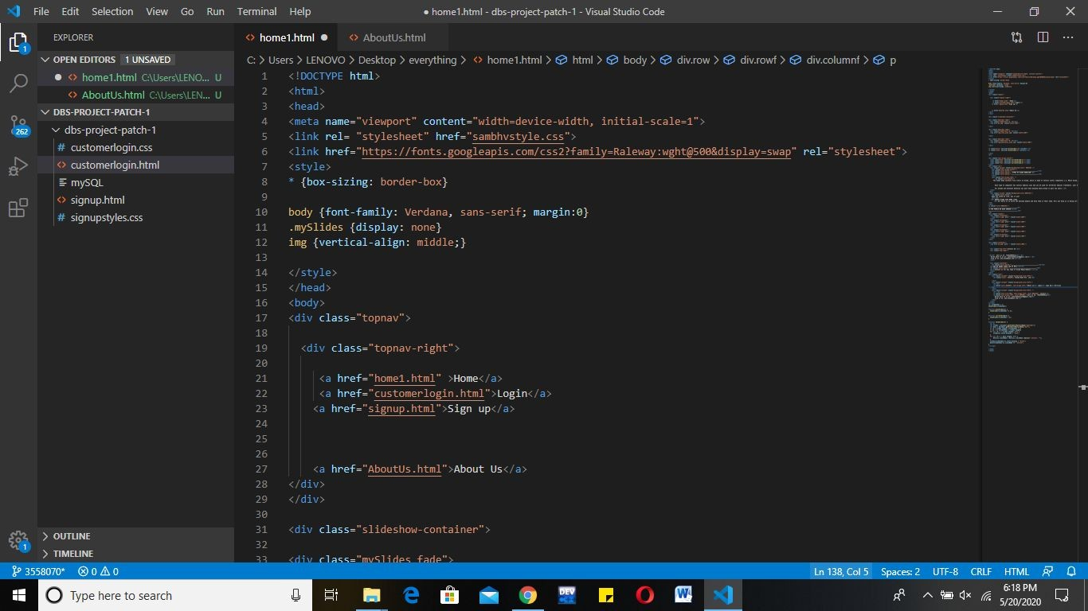

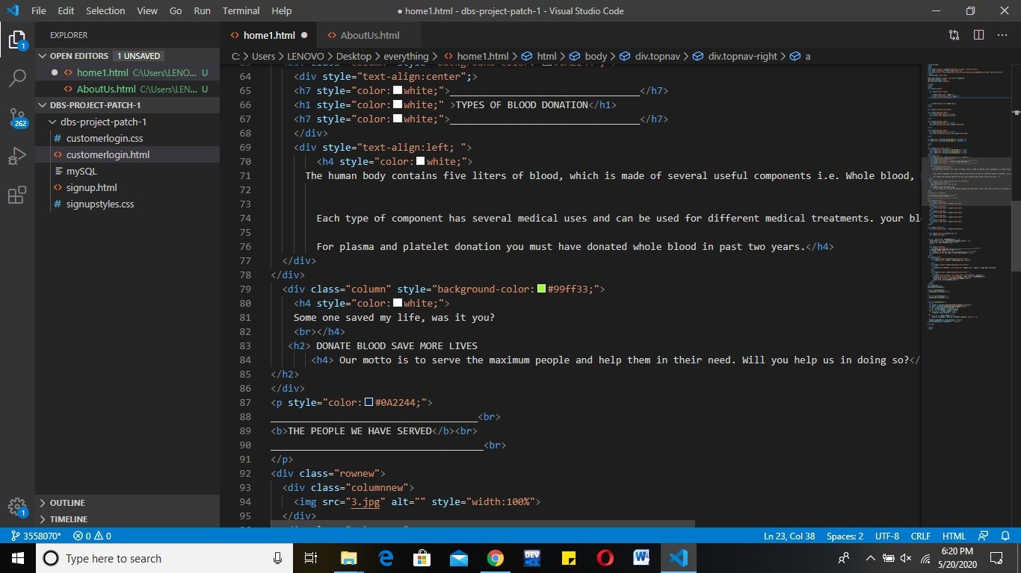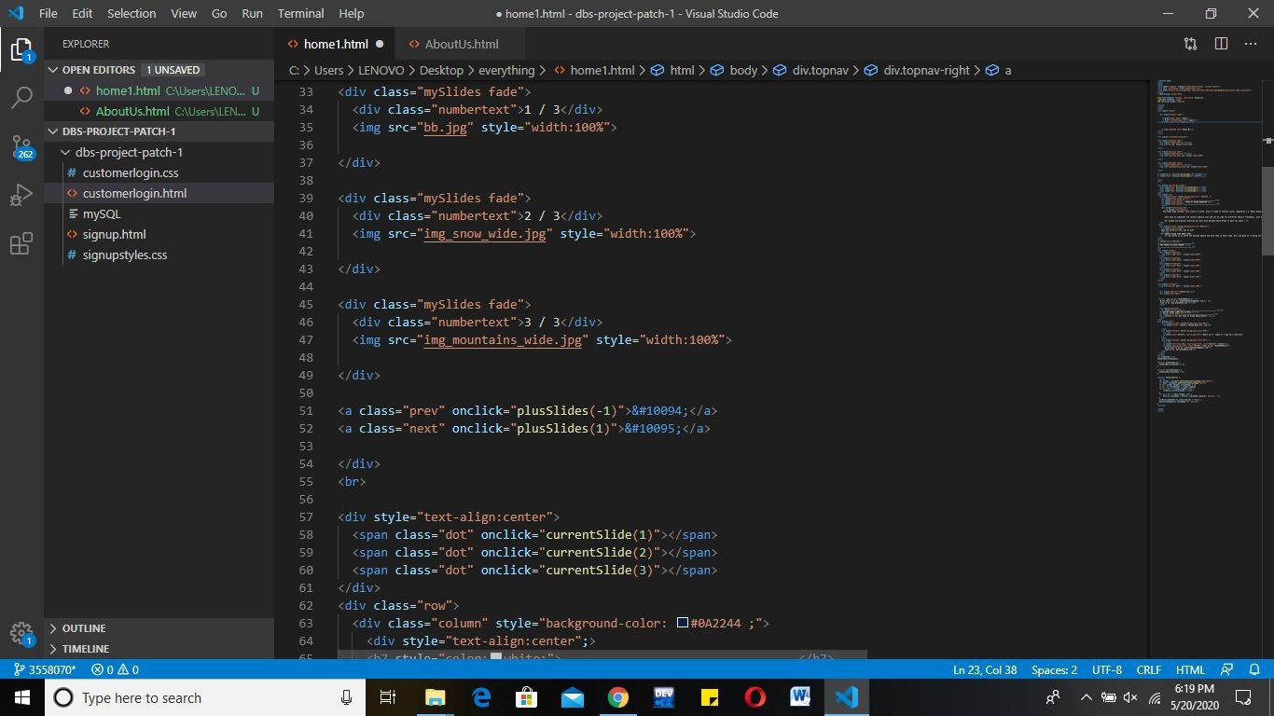

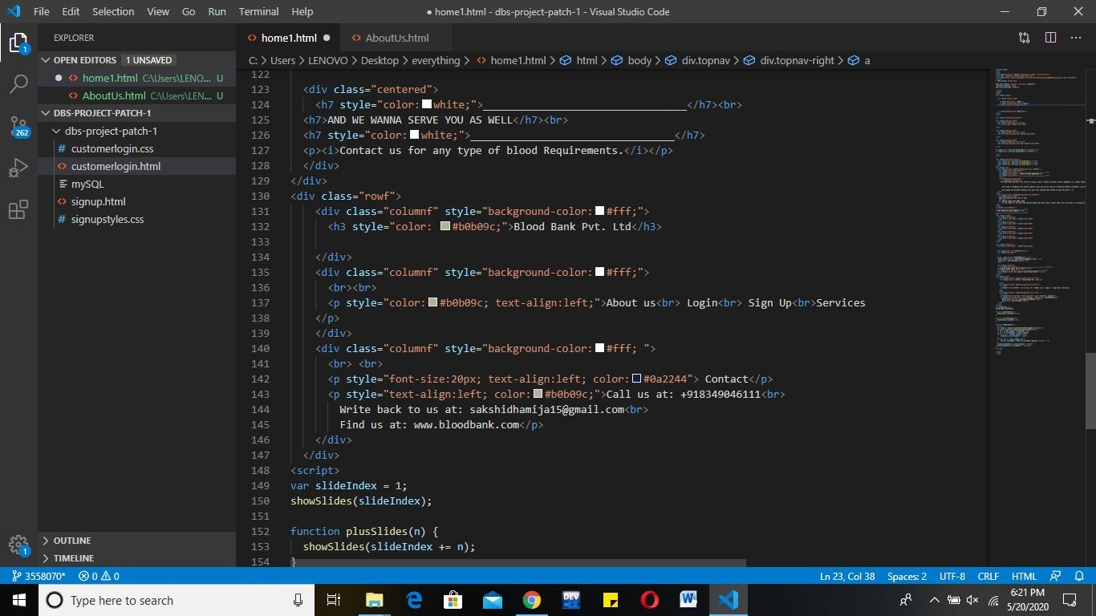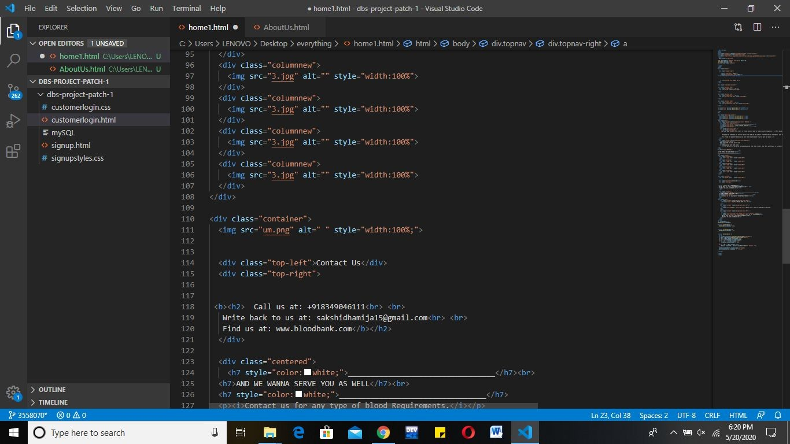

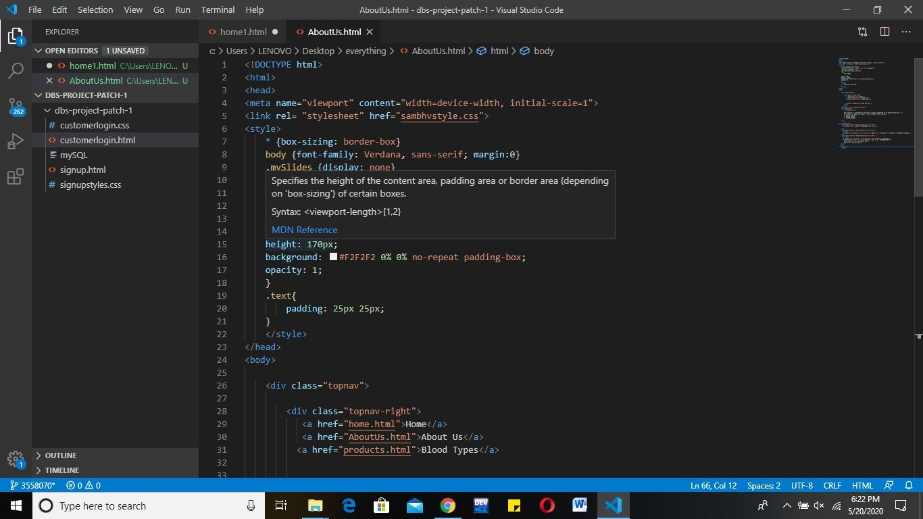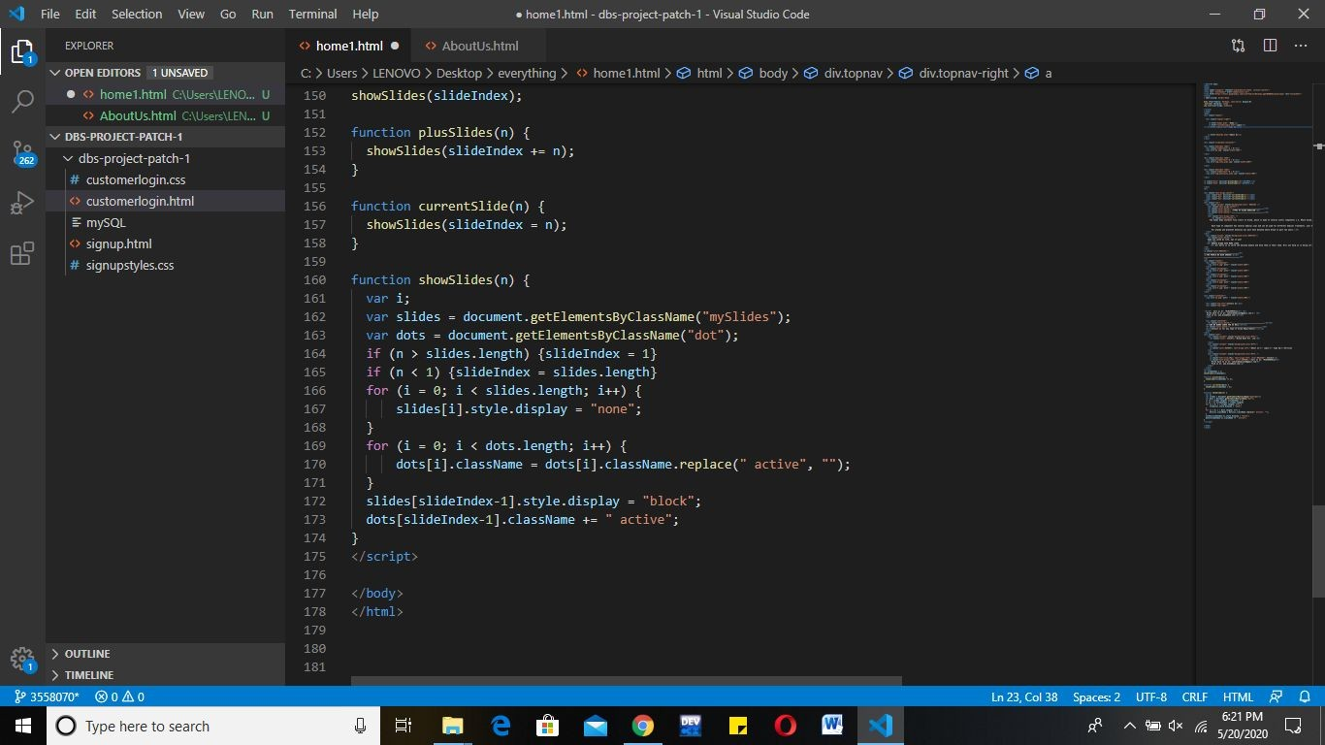

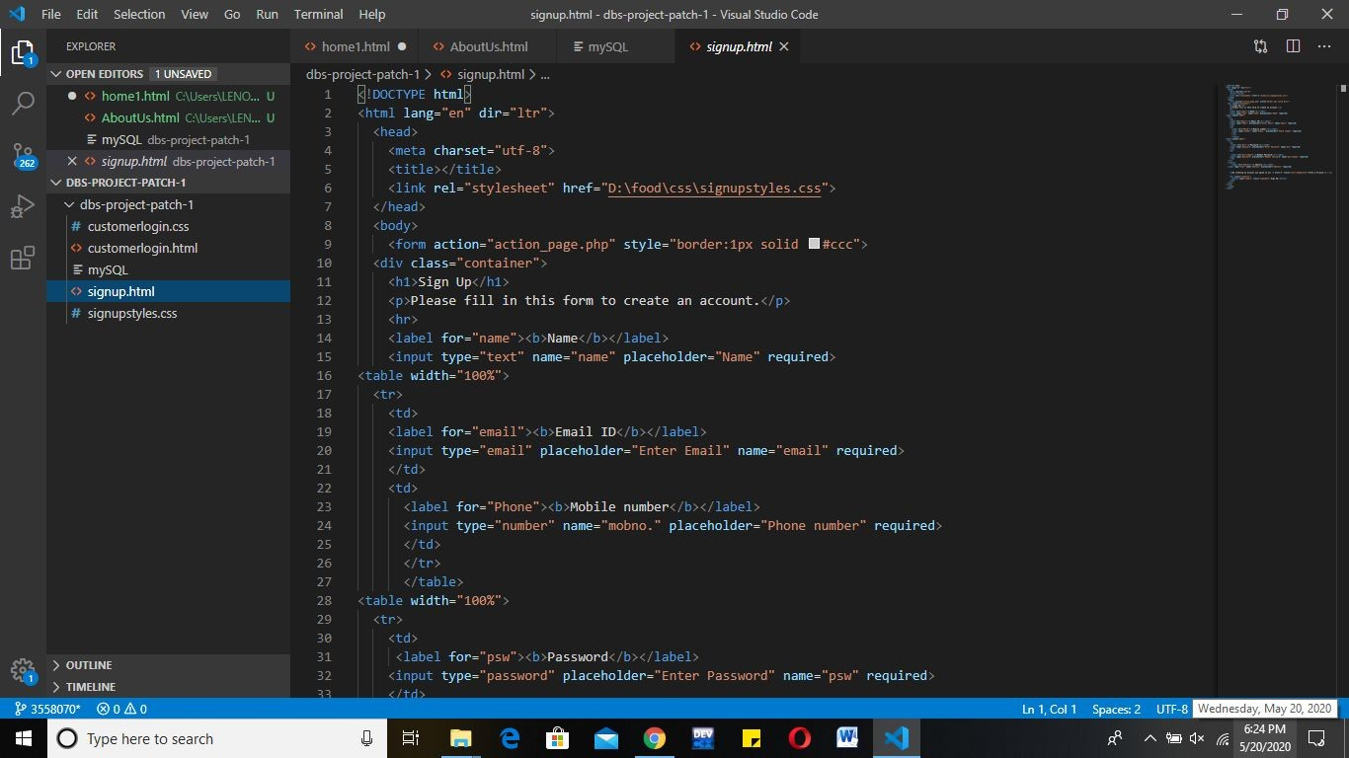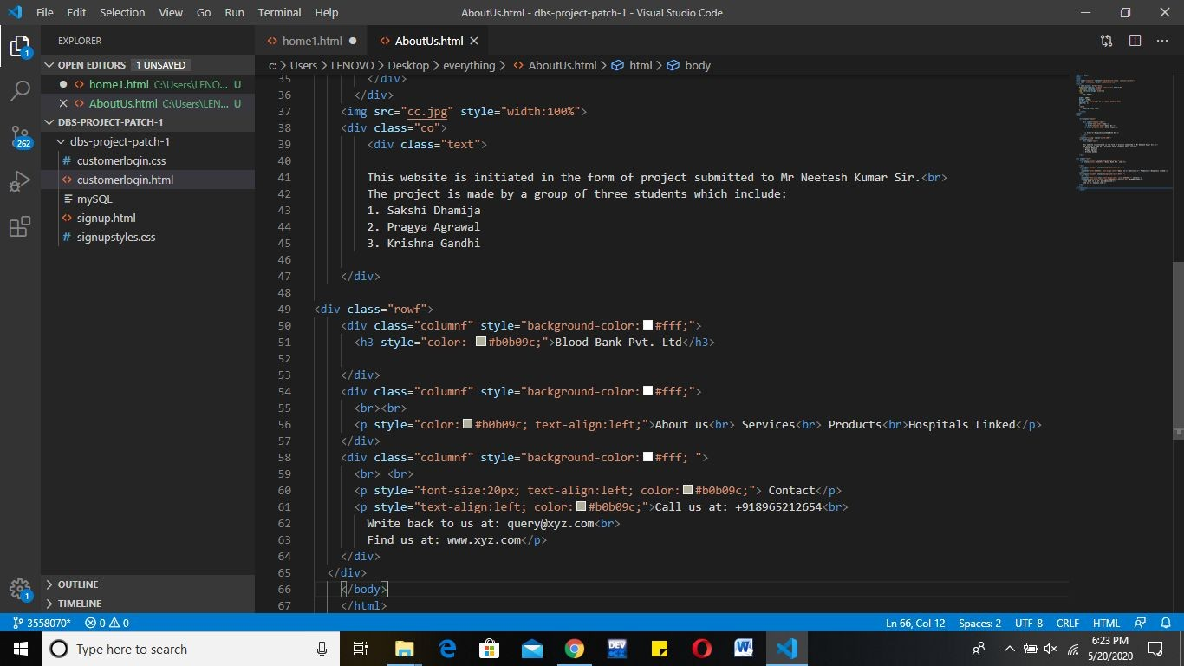

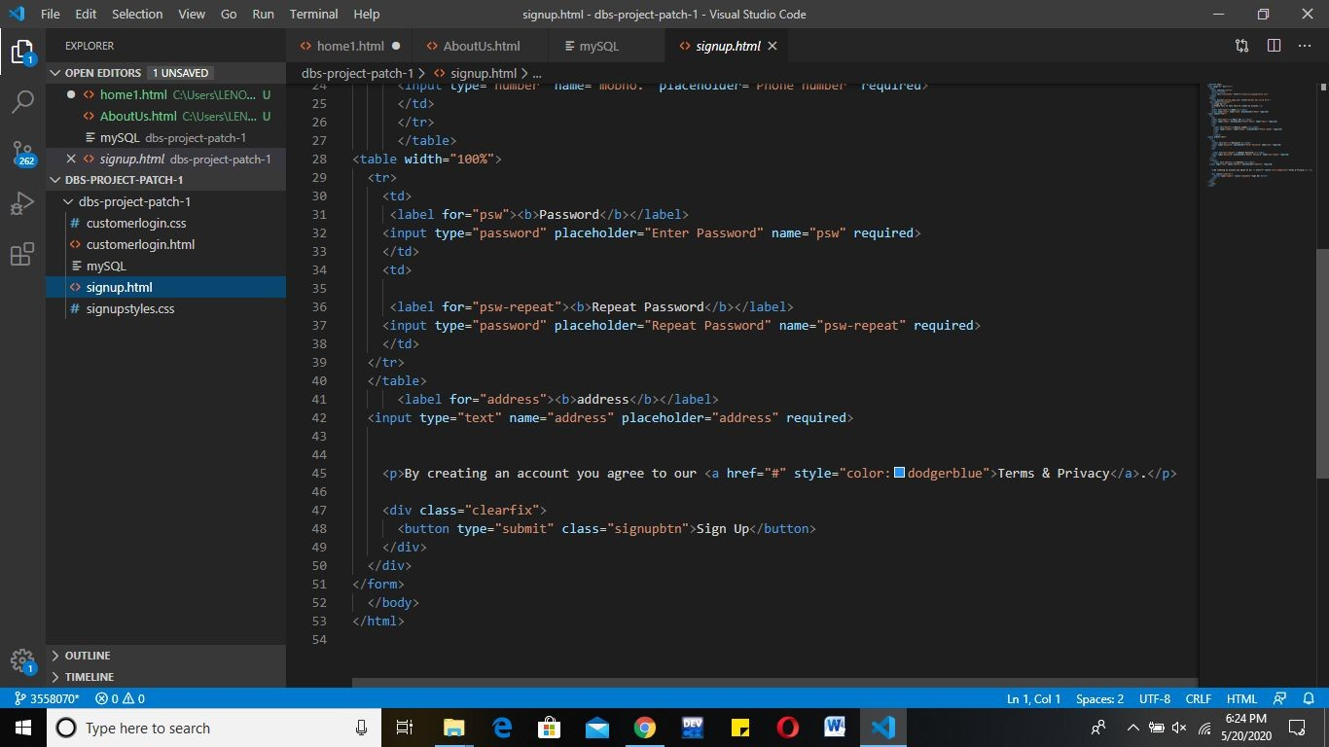

#### The screenshots of the final website are attached below!

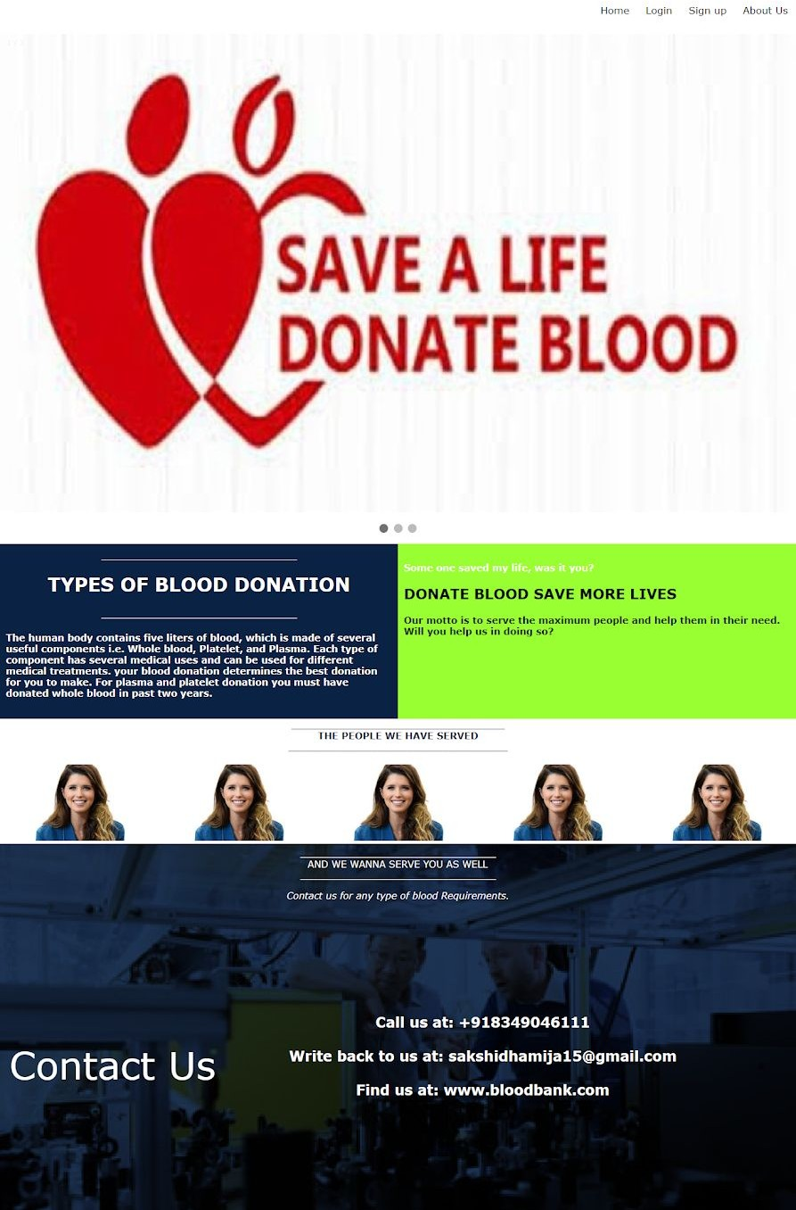

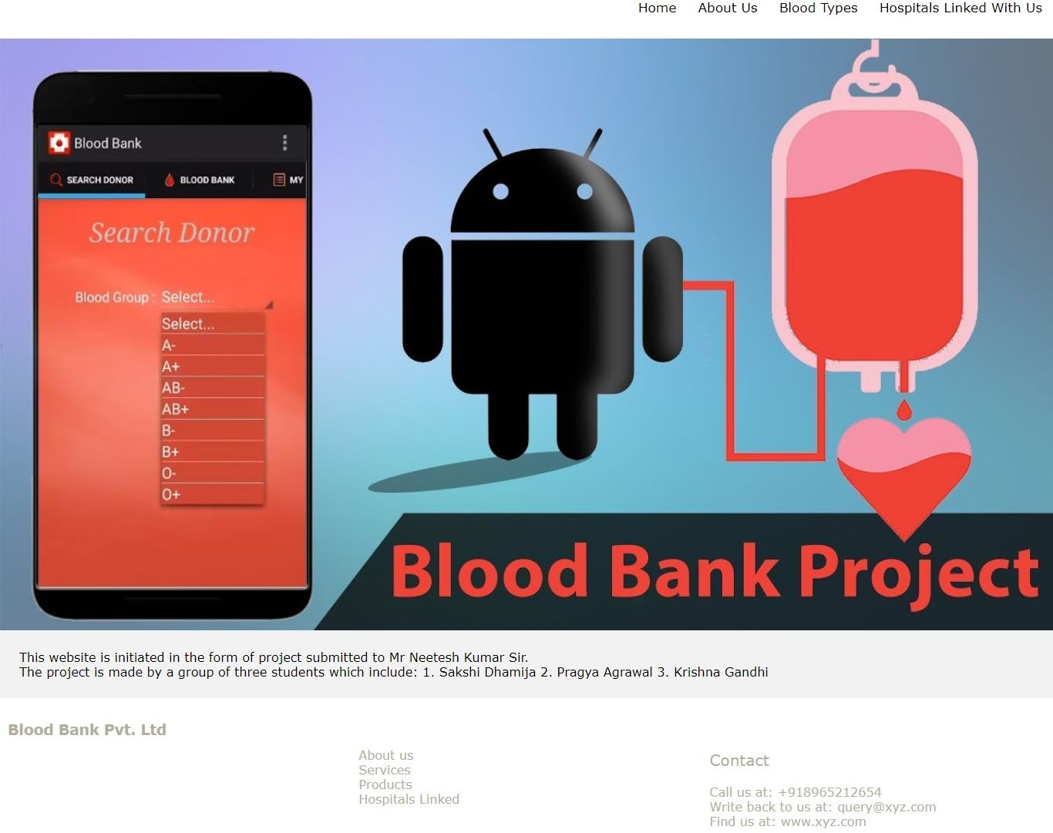

Next, we have created a signup page where a user can sign up and look at the details of the type and amount of blood available!

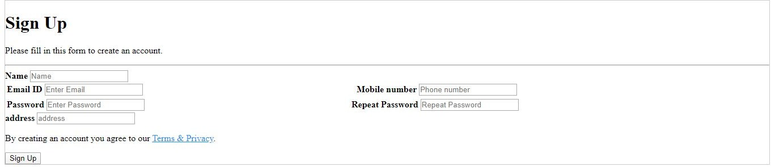

THANKS!